Department of Urdu
Individual Profile

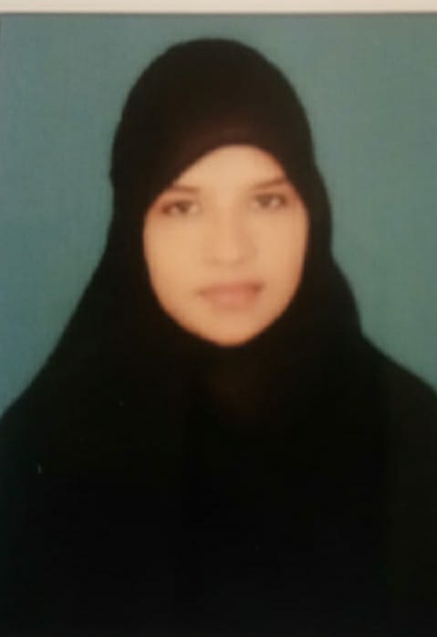

CA Nusrath Banu
IMA (Integrated Master of Arts)
Guest Lecturer in Dept of Urdu

Dob: 09/05/1996
Contact no: 9010147421
Mail id: nussrath.banu@gmail.com
N.S.P.R. GOVT DEGREE COLLEGE (W)
HINDUPUR.

TEACHING EXPERIENCE
3Years
Course | Name of the Working College
UG (BA,B.COM, BSC ) | NSPR GDC (W) HINDUPUR.
UG (BA,B.COM, BSC ) | NSPR GDC(W) HINDUPUR
UG (BA,B.COM, BSC ) | NSPR GDC(W) HINDUPUR

